Assignment day 17

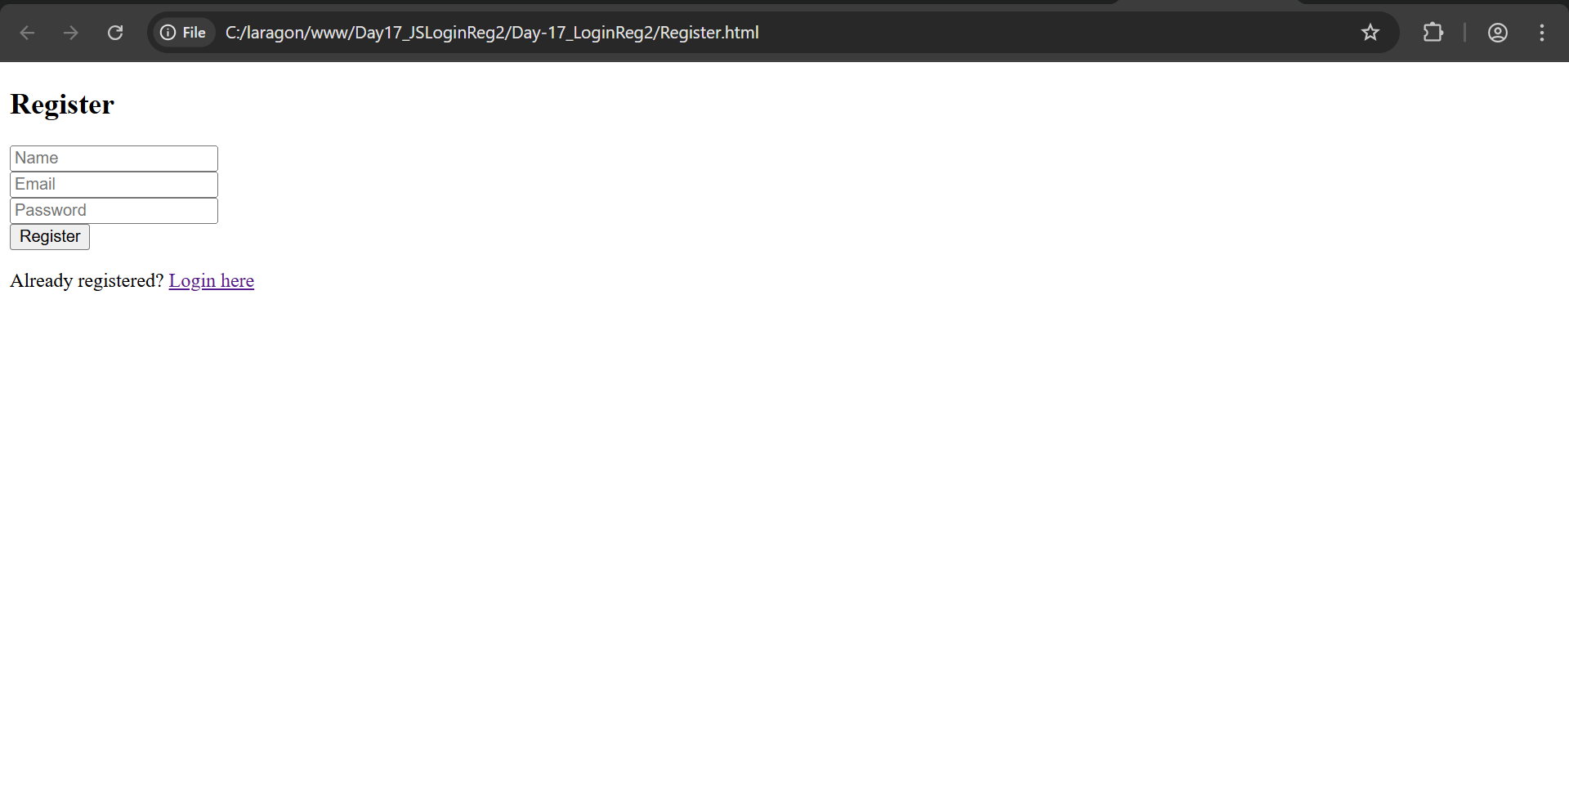

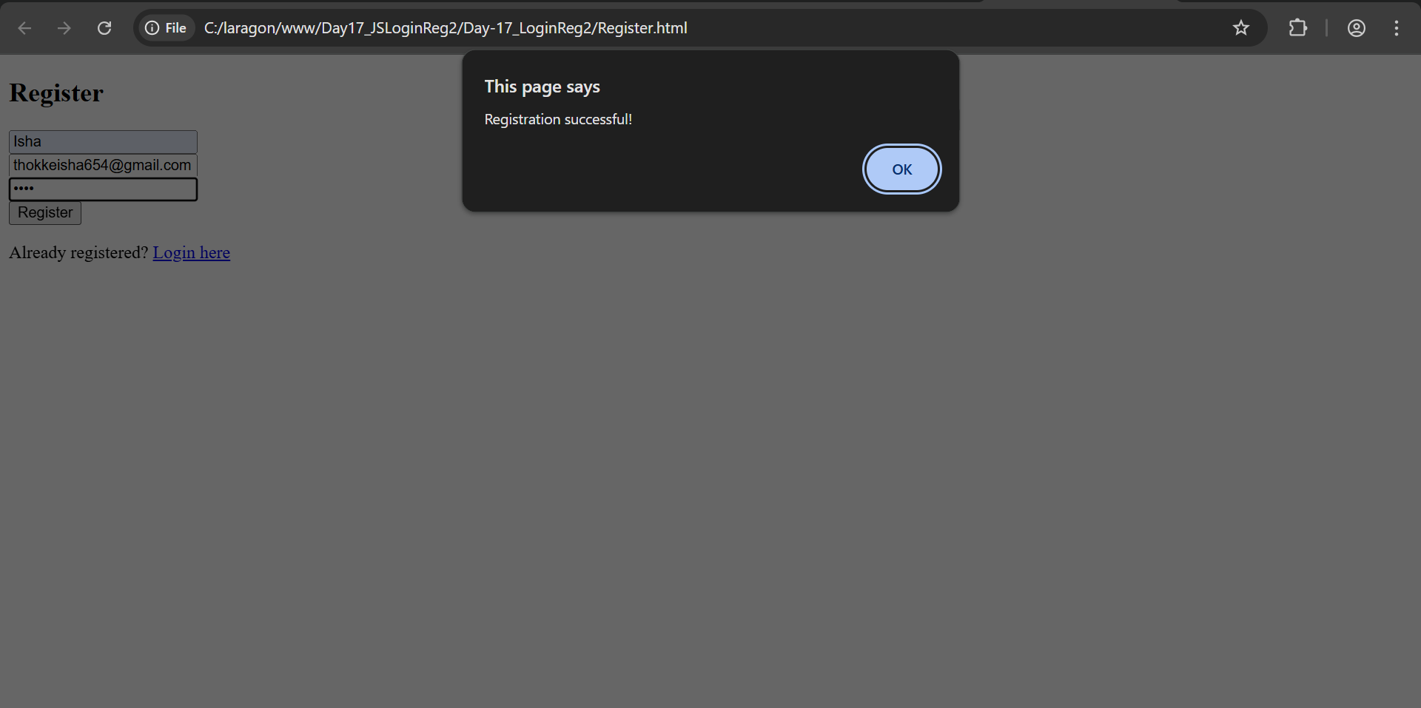

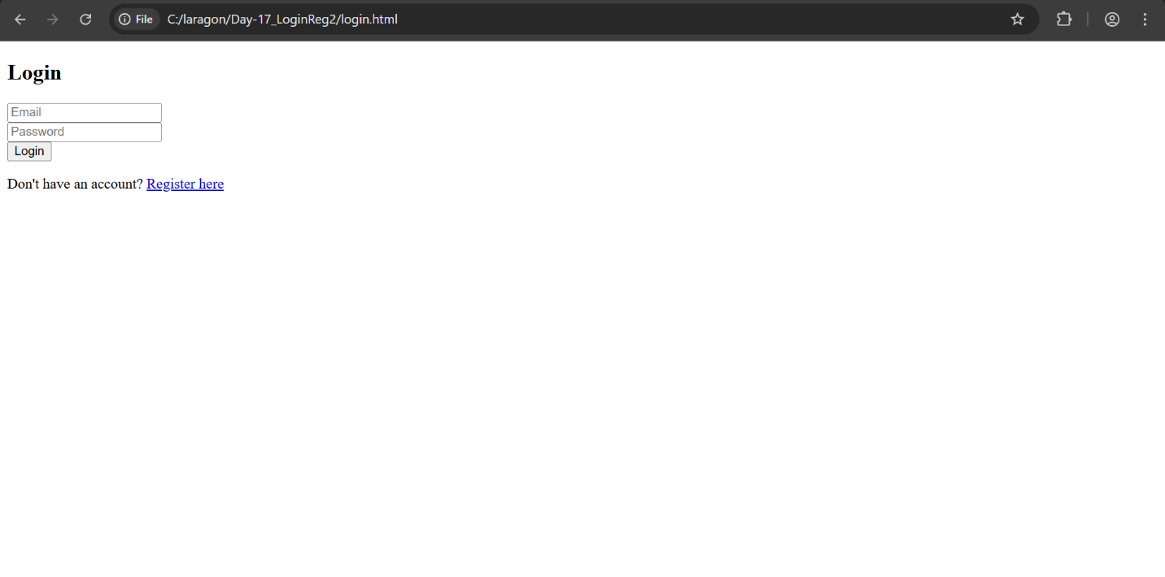

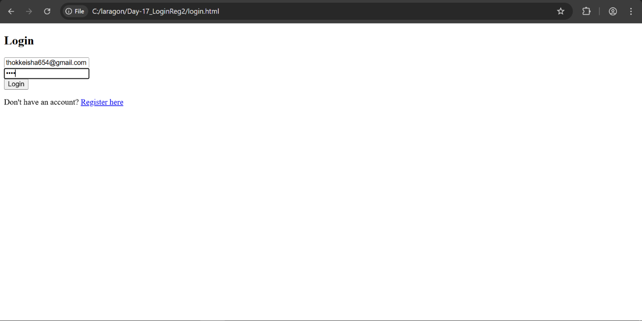

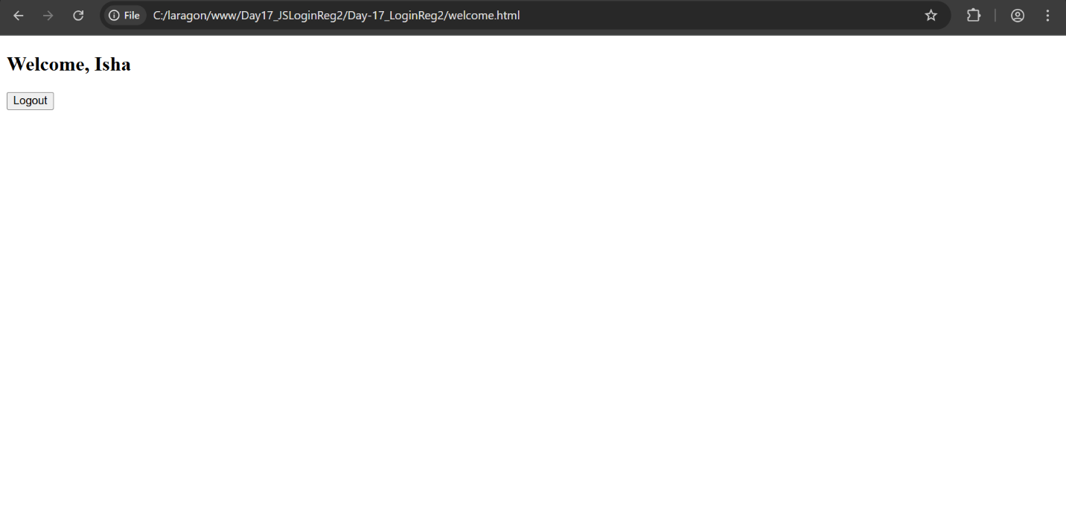

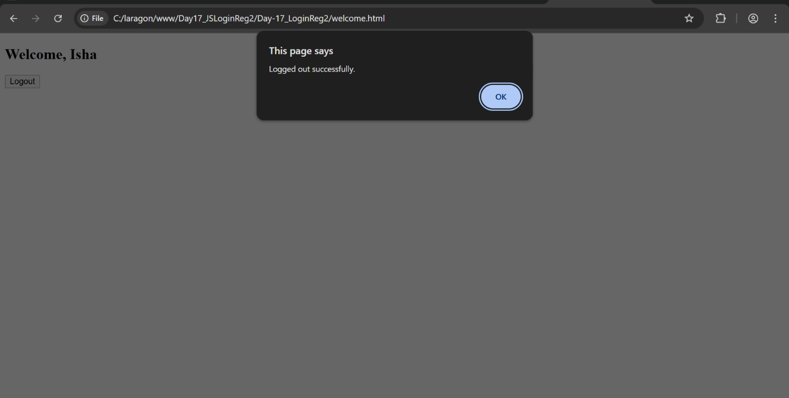

A basic login/register system is made using **HTML, JavaScript, and localStorage/sessionStorage**. You will create a registration page, login page, and a welcome page that displays the logged-in user's name. The system should allow users to **register**, **log in**, **see a personalized welcome message**, and **log out** securely. Proper validation, redirection, and error handling are also required.